InComm

TIBCO Spotfire Analytics for TIBCO API Exchange Manager

Version <1.0>

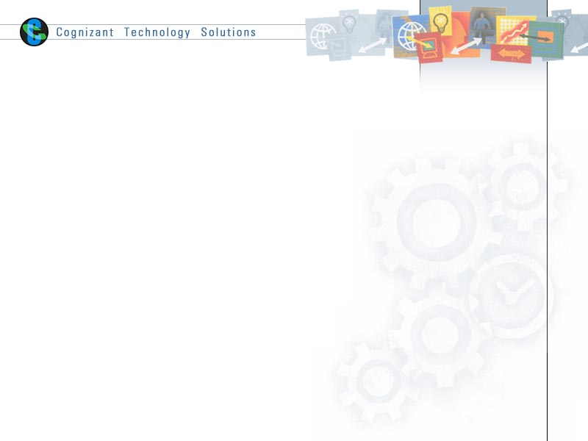

|  |  |  |  |
| --- | --- | --- | --- |
|  | **Prepared By / Last Updated By** | **Reviewed By** | **Approved By** |
| **Name** | Yogesh Basavarajaiah |  |  |
| **Role** |  |  |  |
| **Signature** |  |  |  |
| **Date** | 10 June 2015 |  |  |

Table of Contents

1.0 Document Overview 3

1.1 Document Purpose 3

1.2 References 3

1.3 Definitions, Acronyms and Abbreviations 3

2.0 Install TIBCO Spotfire Server 3

3.0 Configure TIBCO Spotfire Server 10

4.0 Install TIBCO Spotfire Client 18

5.0 Configure TIBCO Spotfire Client 22

6.0 Appendix A – Change Log 24

# Document Overview

## Document Purpose

This document is intended to provide guideline on installing TIBCO Spotfire server & client and to integrate the same with TIBCO API Exchange Manager. This way we achieve analytics of TIBCO API Exchange Manager from TIBCO Spotfire.

## References

Use this section to fill-in reference documents used

|  |  |
| --- | --- |
| ***Document#*** | ***Document Title*** |
|  |  |
|  |  |

## Definitions, Acronyms and Abbreviations

Use this section to fill-in definitions of acronyms & abbreviations used in this document

|  |  |
| --- | --- |
| ***Term, Acronym*** | ***Definition*** |
|  |  |
|  |  |

# Install TIBCO Spotfire Server

**Step1**: Double click on “setup-win64”

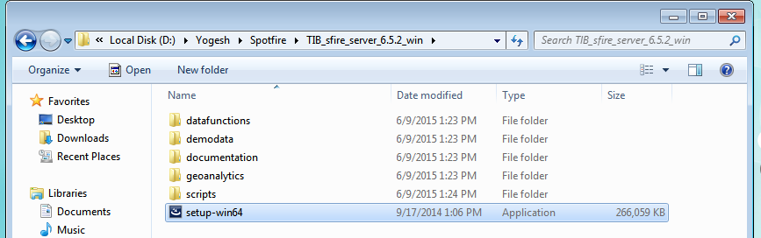

**Step2**: Click on Next when below screen is prompted:

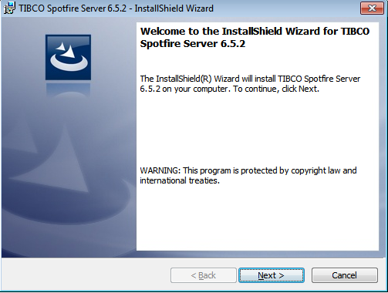

**Step3**: Select radio button “I accept the terms in the license agreement” and click on Next button.

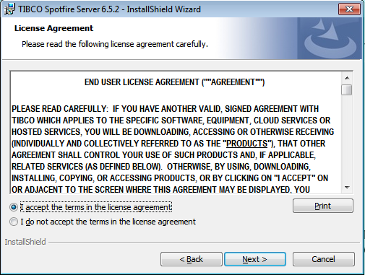

**Step4**: Select radio button “Do not download third party components” and click on Next button.

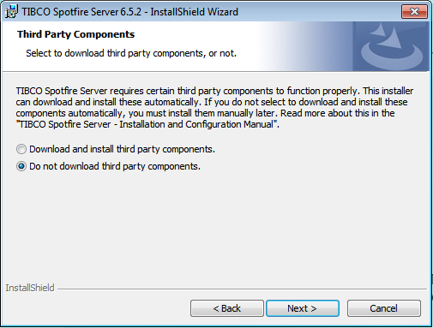

**Step5**: Choose the destination folder where the software needs to be installed then click on Next button.

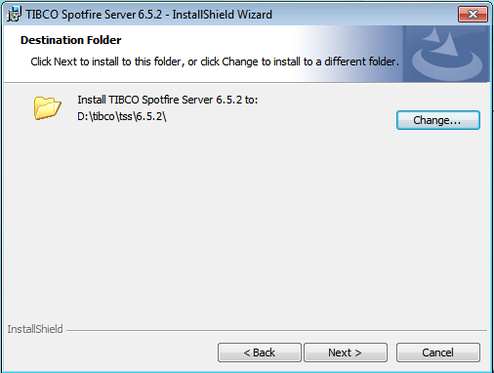

**Step6**: Select radio button “Create Windows Service” and click on Next button.

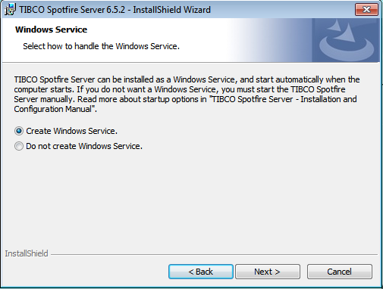

**Step7**: Give a valid Spotfire Server Port (eg.55566) and click on Next button.

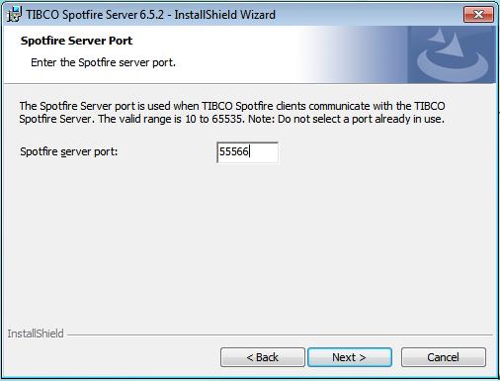

**Step8**: Click on Install button to start installation.

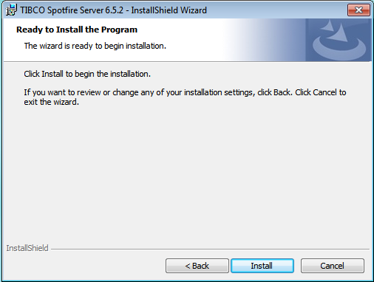

**Step9**: Click on Finish button to complete installation. TIBCO Spotfire Configuration Tool window will be displayed after installation is completed.

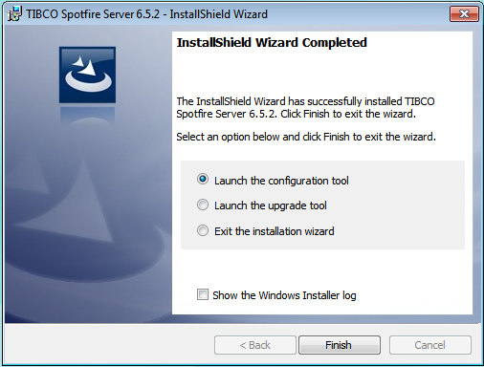

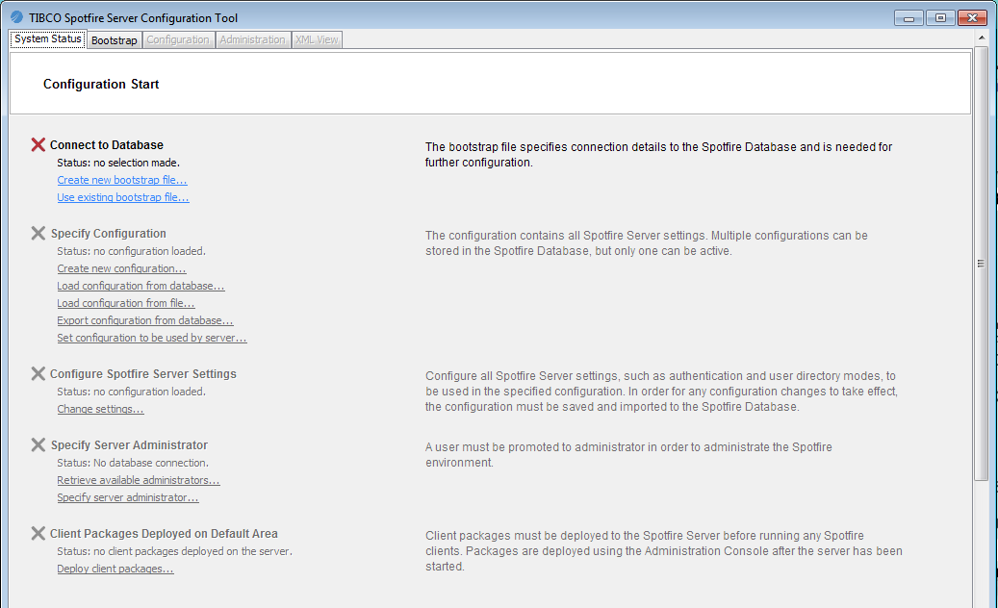

# Configure TIBCO Spotfire Server

**Step1**: Create Database user in Oracle for TIBCO Spotfire Server.

Eg. Username= spotfire

Password= spotfire

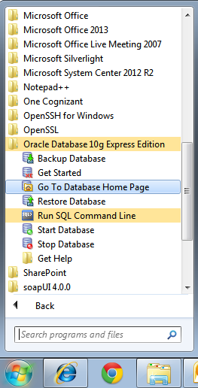

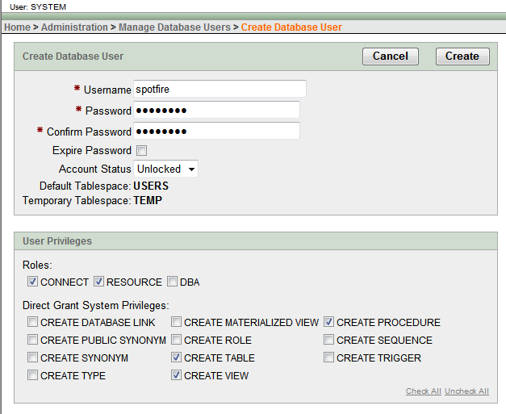

**Step2**: In the TIBCO Spotfire Configuration Tool window click on Create new bootstrap file, in the below window type following details:

Database username: (eg.spotfire, which was created in previous step)

Database password: (eg.spotfire, which was created in previous step)

Database URL: eg.localhost

SID: XE

Configuration Tool password: eg.spotfire

Finally click on “**Create Bootstrap**” button.

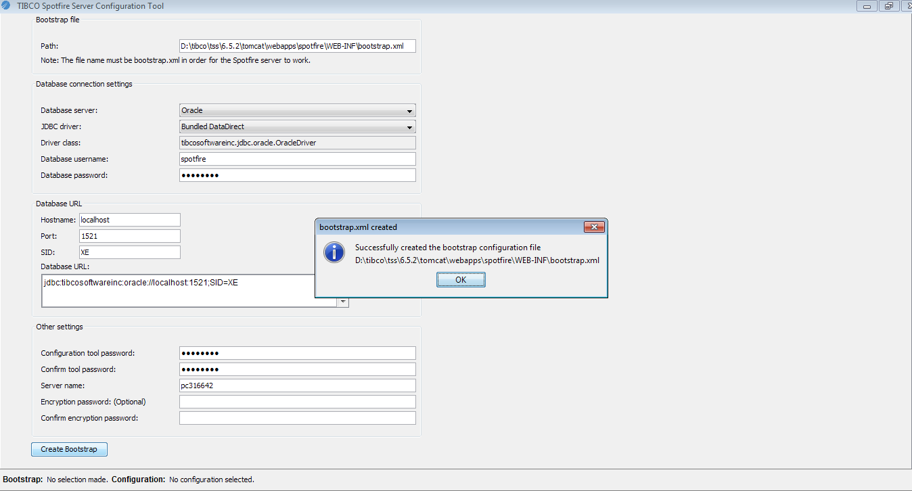

**Step3**: Go back to TIBCO Spotfire Configuration Tool and click on “Specify server administrator” link under “Specify Server Administrator” section.

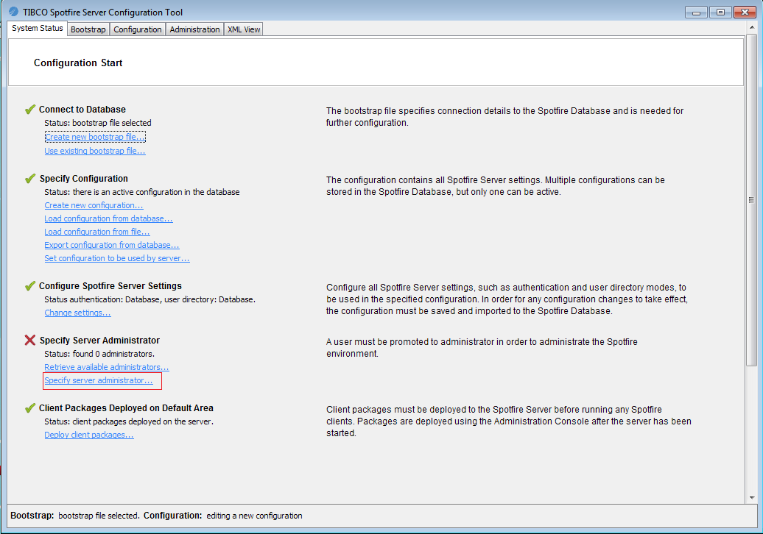

Here under “Create new user” section create user by name “spotfire_client” and type password as “spotfire” and promote user to Administartors.

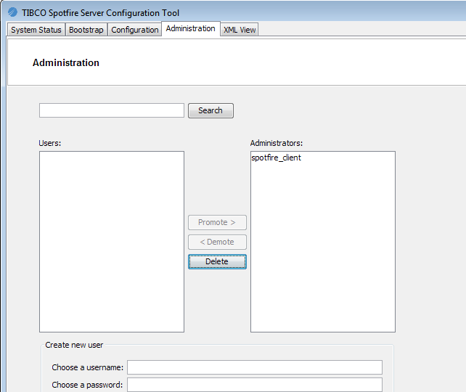

**Step4**: Go back to TIBCO Spotfire Configuration Tool and click on Deploy client packages:

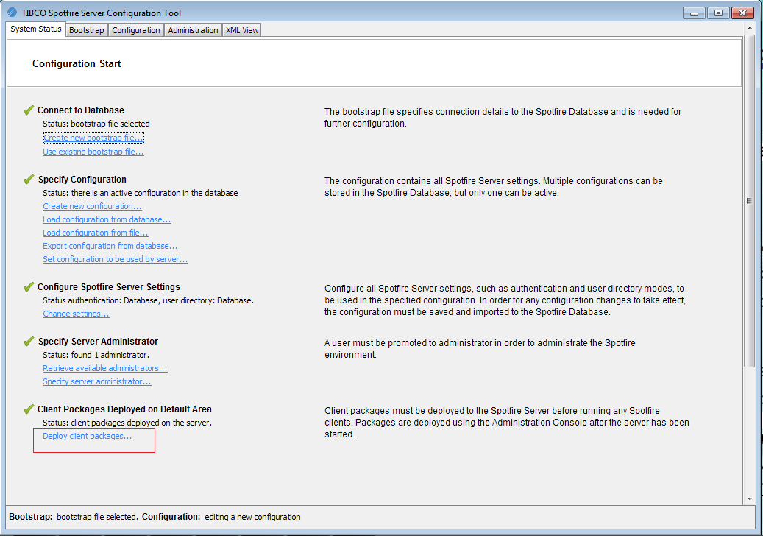

Here select “Spotfire.Dxp.sdn” located in path “TIB_sfire_deploy_6.5.0_win\Products\TIBCO Spotfire Distribution\”

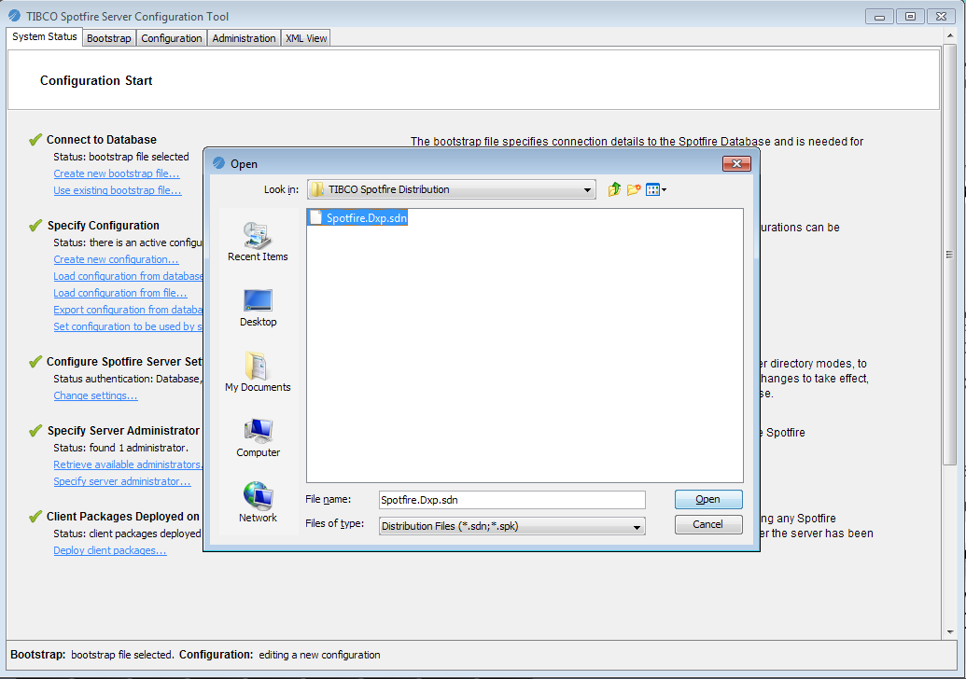

Now we get message - “Uploading file. Please wait..” and finally when upload is completed we get below pop up message, Click OK.

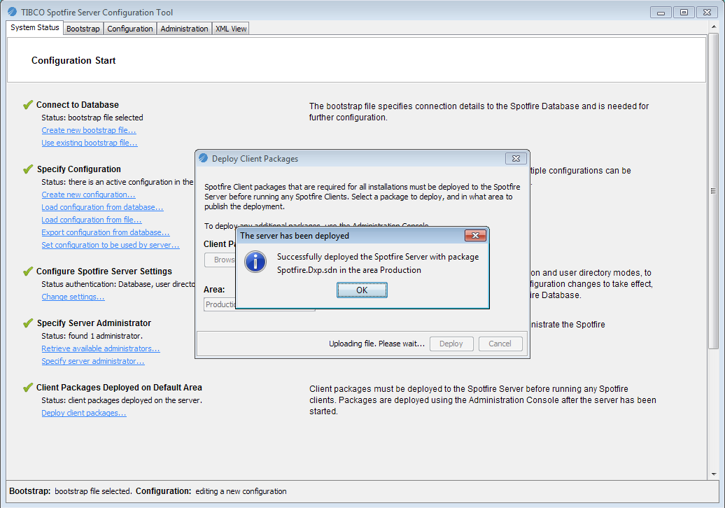

**Step5**: Open services.msc then select TIBCO Spotfire Server and click on Start the service. Now the status gets changed to “Started”.

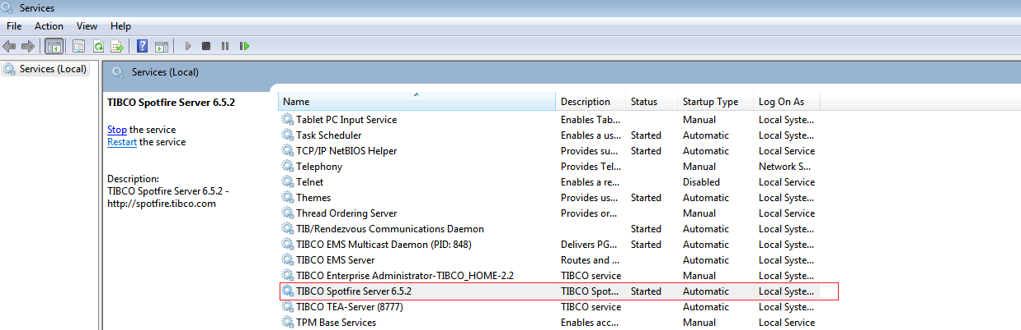

# Install TIBCO Spotfire Client

**Step1**: Open “setup-6.5.2” located in location \tibco_spotfire_client_6.5.2\TIB_sfire_6.5.2_win\Products\TIBCO Spotfire Installer

And click on Run.

Click Next on below window:

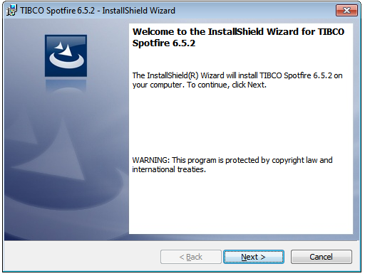

**Step2**: Select Radio button “I accept the terms in the license agreement” and click on the “Next” button.

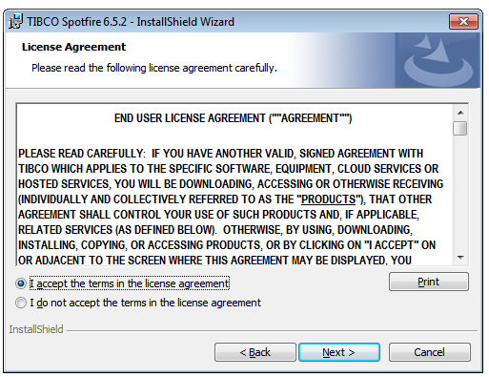

**Step3**: Type <http://localhost:55566/> for Server URL,55566 is port no. given during Spotfire Server setup.

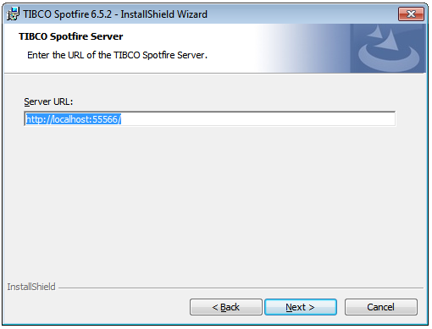

**Step4**: Click on Install button in below window:

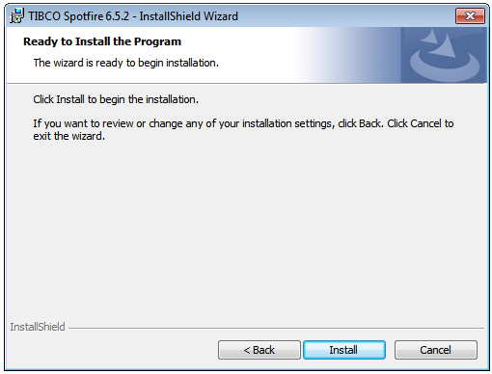

**Step5**: Click on Finish button to complete installation.

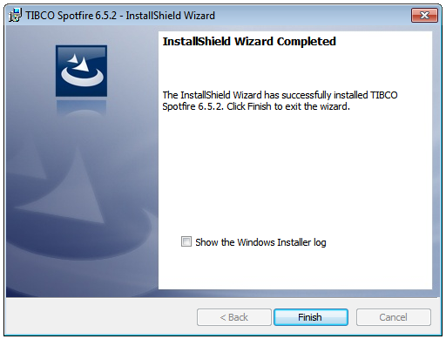

# Configure TIBCO Spotfire Client

**Step1**: Open TIBCO Spotfire Client and type username & password created in Spotfire server.

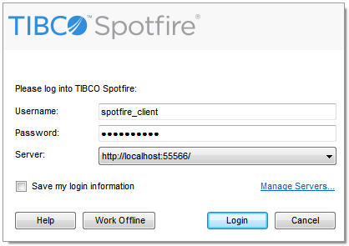

**Step2**: On successful login we get pop up message saying new modules are available, we can skip download by clicking on “Later” button here.

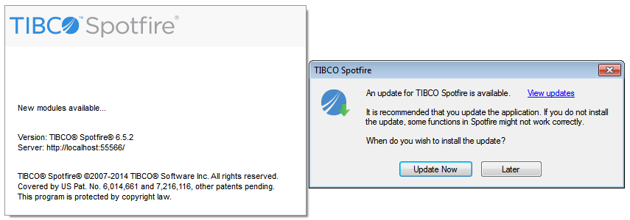

**Step3**: Follow Task B, Task C and Task D (Chapter 15 under section Reporting/Spotfire Configuration) to get reporting/analytics from TIBCO Spotfire. Attached below is the document to be referred.



# Appendix A – Change Log

|  |  |  |  |  |
| --- | --- | --- | --- | --- |
| ***Version Number*** | ***Changes Made*** | | | |
| V1.0 | Initial baseline created on 10-June-2015 | | | |
| Vx.y |  | | | |
| **Section No.** | **Changed By** | **Effective Date** | **Changes Effected** |
|  |  |  |  |
| Vx.y |  | | | |
| **Section No.** | **Changed By** | **Effective Date** | **Changes Effected** |
|  |  |  |  |
| Vx.y |  | | | |
| **Section No.** | **Changed By** | **Effective Date** | **Changes Effected** |
|  |  |  |  |